Introduction to JUICE and CAMPER

Contents

About the JUICE Site 2

Basic site components—modules and modulettes (mini-lessons) 2

Additional site components 4

Using CAMPER to build JUICE 4

Supported Browsers 4

What is CAMPER? 4

Basic user interface—CAMPER tables 5

CAMPER tables and what they are used for 8

CAMPER Roles and Permissions 9

CAMPER data and the JUICE site 10

Basic steps for making a program 11

The importance of clearing your cache and how to do it! 12

# About the JUICE Site

## Basic site components—modules and modulettes (mini-lessons)

The building block for the JUICE site is the **module**. You can set whether a module will appear in the site or not. The JUICE Dashboard / Home page for a specific program displays all the modules for that program that have been included in the site:

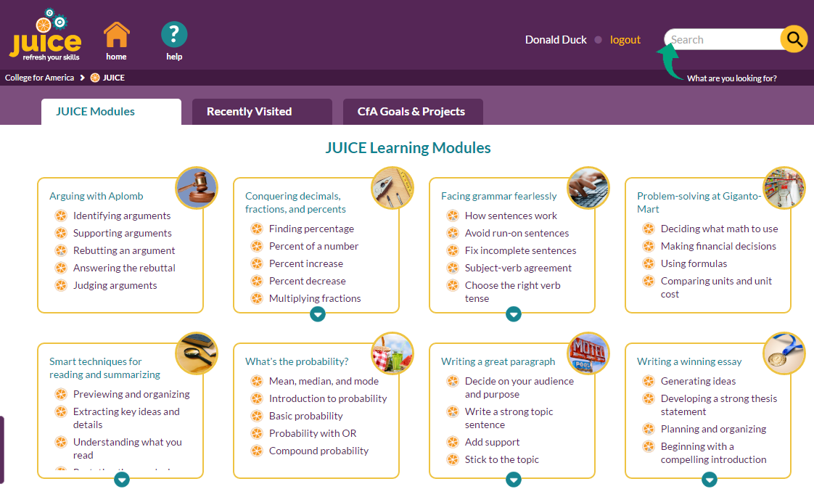

modules

Each module contains one or more “modulette groups” (mini-lesson groups), and each modulette group contains one or more modulettes (mini-lessons):

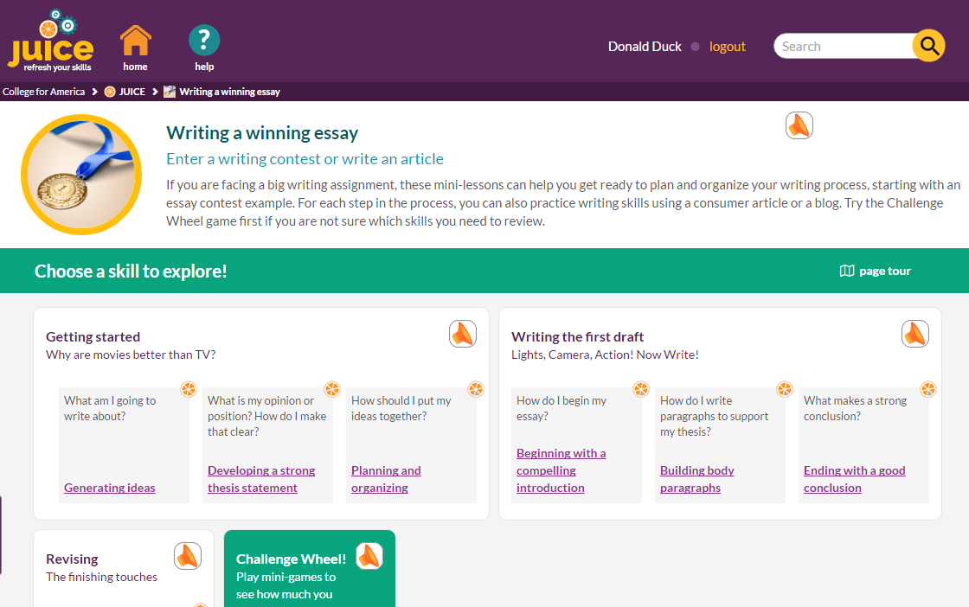

modulettes

modulette groups

Each modulette is configured to have multiple parts (tabs). Each tab can have more than one choice (track). Each track has a content player (widget)—a track and widget together are called a widget instance. Each widget instance has a content file. Together, the widget instance and the content file deliver the learning experience.



Track + widget = widget instance

tracks

tabs

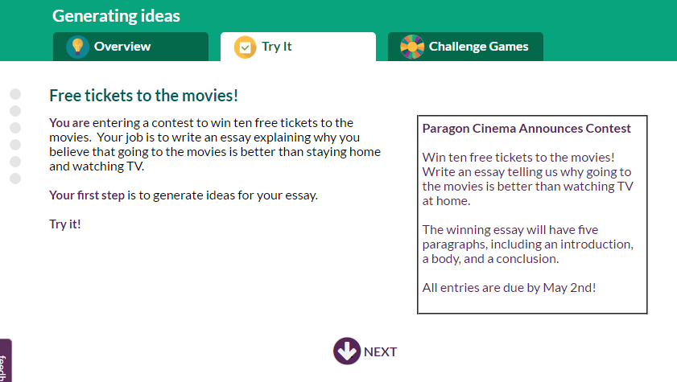

widget instance + file = student experience

## Additional site components

The site has additional components that make up the complete user experience. Some of the components are separate files, while others are defined directly in CAMPER.

Files:

**Audio:** Modules and modulettes both play **audio narration files**. Modulettes may also make use of an **audio map** to override default audio narration files.

**External files:** Modulettes can link to **external files** (ancillary files) that contain content that doesn’t fit within the framework of the mini-lesson. These can include images or PDF documents that contribute to the content of the mini-lesson.

**Photos and images:** Modules, Try its, and Challenge Games use photos or graphic images as identifiers in the site.

Defined directly in CAMPER:

**Projects:** The Goals and Projects view of the JUICE Dashboard shows a list of **projects** grouped by goals—and the modules that support each project.

**Rubric criteria:** Both modules and modulettes can be mapped to **rubric criteria**. The rubric criteria is used by Search.

# Using CAMPER to build JUICE

## Supported Browsers

Use Chrome or Firefox to work in CAMPER. If you wish to add images to your Overview and Try it content files, use Firefox. This is the only browser that allows you to copy and paste the images directly into the authoring template.

## What is CAMPER?

**CAMPER** is the JUICE **C**ontent and **a**uthoring **m**anagement and **p**roduction system.

CAMPER uses a Quickbase database to manage and store the following:

|  |  |
| --- | --- |
| Program structure and customizations | * Modules and mini-lessons (modulettes) that make up each program and appear on the dashboard * Access to program customization tool |
| Module structure and attributes | * Mini-lessons included in each module * User interface text that appears on the module page in the site * Additional search criteria—tags and rubrics * Goals and projects page correlations * Competency correlations |
| Mini-lesson (modulette) structure and attributes | * Parts, choices, content players for each mini-lesson * File names for Overview, Try it and Challenge game content files * User interface text that appears on the mini-lesson pages in the site * Additional search criteria—tags and rubrics * Sub competency correlations * Mappings for audio files |
| External files | * External file names and management tools |

CAMPER also provides tools for uploading image and audio files for modules and modulettes.  
  
Content files played by the modulettes, external files, audio files, and the module, try it, and challenge game photos and images are stored in Amazon S3.

## Basic user interface—CAMPER tables

The information in CAMPER is stored in records that are grouped into data tables. Each data table can be accessed by clicking on the table name in the button bar at the top of the CAMPER page.



The data tables display the most important information about each database record in rows:

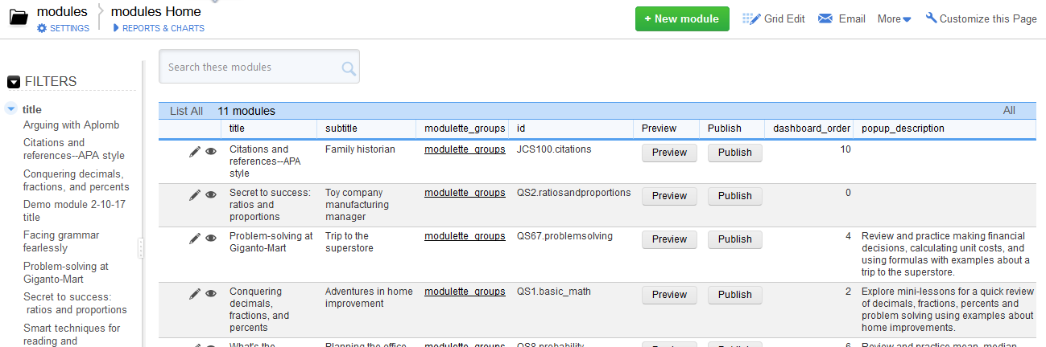

You can filter the rows being displayed by using the filters to the left of the table, or by entering text in the “Search” box that is above the table.

Each row has a pencil and an eye icon in the left most column.

* Clicking the pencil loads an editable form with all of the data associated with the record.

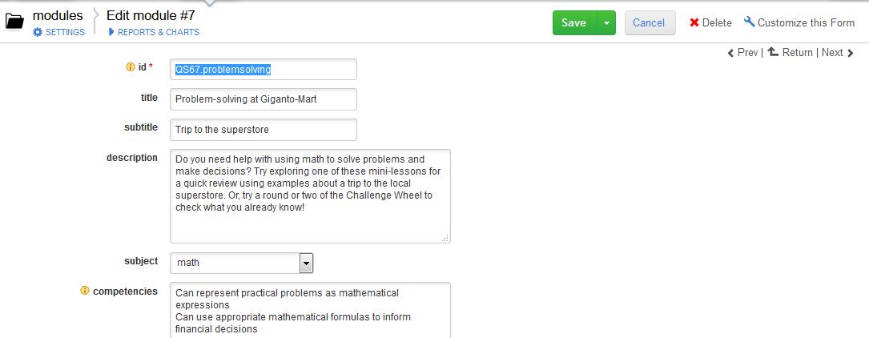

* Clicking the eye loads a “read-only” view of the form showing all the data associated with the record. The read-only view can be switched to the editable view by clicking an Edit link at the top of the page.

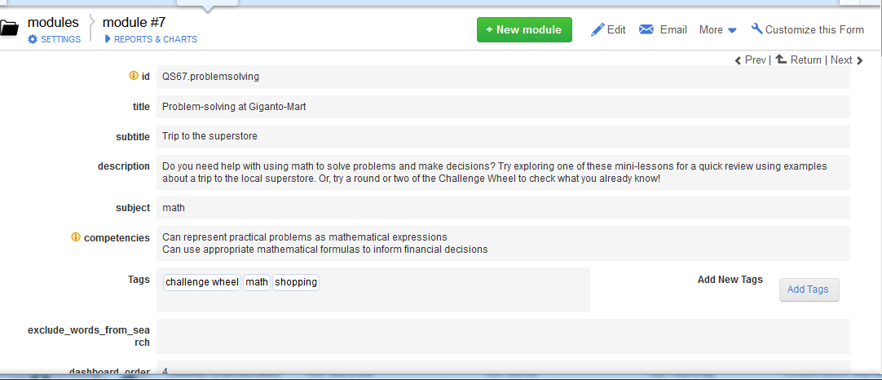

You can also edit the data showing in the table by clicking the Grid Edit link to the upper right of the table. This will show the table data in an editable grid.



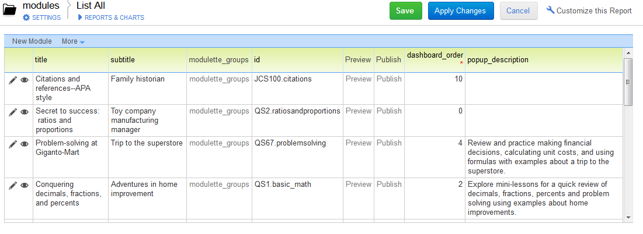

Some CAMPER tables allow you to add records, while others do not.

If you can add a record to a CAMPER table, the table page will display a green “New” button next to the Grid Edit button.



Some of the CAMPER tables provide access to alternate views designed for specific functions. For example, the modulettes table has an alternate view that allows you to use Grid Edit to add tags. You can see the available reports for any table by clicking REPORTS & CHARTS underneath the table title:

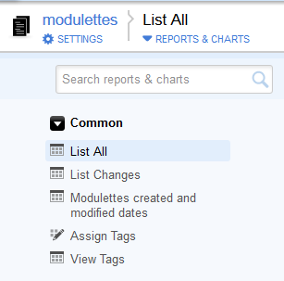

## CAMPER tables and what they are used for

Note: **Participants** (authors) only have access to the files table.

| **Table** | **What it is for** |
| --- | --- |
| Home | Program management—import modules, program customization settings  Program level publishing functions: Dashboard, Search  Option to preview the site dashboard. |
| Users | Managing users and their roles |
| modules | Making or editing modules  Uploading module images and audio files |
| modulettes | Making or editing mini-lessons and their attributes.  Uploading mini-lesson Try it and Game choice images |
| tabs |
| tracks |
| widget instances |
| modulette-sub_competencies |
| files | Creating content for mini-lessons  Uploading audio files |
| ancillary_files | Adding and managing external files |
| rubrics | Adding rubric criteria to be used for Search; mapping rubric criteria to modules |
| modulette_rubrics | Mapping rubric criteria to mini-lessons |
| projects | Adding projects to display on the Goals and Projects page |
| module_instances | Mapping modules to the projects to display on the Goals and Projects page |
| audio_maps | Making an override for the default audio files |
| modulette_groups | Holds the data for the modulette groups—typically not used for editing |
| widgets | Holds the data for the available widgets—not used for editing |

## CAMPER Roles and Permissions

**CAMPER** supports three user roles:

| **Role** | **Permissions** |
| --- | --- |
| JUICE team **Administrator** | * Access and manage users in all programs * Create or customize tables, fields, reports, or forms * Import content from core JUICE * Create new content * Lock files for editing * Edit locked files * Rename mini-lesson content files or ancillary files |
| Program **Manager** | Same rights as admins in their own programs, except that they CANNOT   * Manage users * Create or customize tables, fields, reports, or forms * Rename mini-lesson content files or ancillary files |
| **Participants** (Authors) | * Special view of the CAMPER Home page * Access to only the files table in their own programs * Edit content files unless they are locked * Preview content files * Set file status |

A JUICE administrator needs to invite all users into a new program via an email invitation. A program needs at least one manager.

Once users are registered in the program, the JUICE admin team must add them to groups that allow access to CAMPER Common, which hosts the code that is used across all programs. If a user does not have access to CAMPER Common, most of the functionality in CAMPER will not work properly. Managers must also be given access to Core JUICE so that the “import modules” table displays properly.

# CAMPER data and the JUICE site

The JUICE site reads data from text or image files that are stored in the Amazon S3 cloud.  
  
When you edit a module or modulette in CAMPER, you use a Quickbase database form, and the data you enter is stored in QuickBase. You must go through an additional Publish step to write your changes into the text files that are stored in S3.

When you edit a content file, the authoring template actually saves the data directly into a text file in S3. There is no publishing step for content files if you want to see your data on the JUICE dev server.

When you upload image files and ancillary files, these are also uploaded directly to S3.

JUICE Dev Site

CAMPER UI

MODULES MODULETTES CONTENT, ANCILLARY, and   
 IMAGE FILES

Amazon S3

CAMPER DATABASE

PUBLISH

# Basic steps for making a program

Documentation for all of these steps is available in the How to make JUICE directory.

1. Create the new program and add users to it (JUICE administrator task)
2. Customize the program’s site UI and import modules from core JUICE
3. Publish modulettes, modules, and dashboard to dev site.
4. Customize imported modules and mini-lessons as desired—update audio narration files as needed or disable narration.
5. Add new modules and mini-lessons as desired—add audio narration files as needed or disable narration.
6. Publish updated modulettes, modules, and dashboard to dev site.
7. Add ancillary files as needed
8. Add rubrics and associated modules and mini-lessons if desired for Search
9. Add projects and associated modules if desired for the Goals and Projects page
10. Publish modulettes, modules, dashboard, AND Search to dev site.
11. Upload photos and images
12. When everything is ready, promote it via a publish of ALL components to the QA and production servers.

# The importance of clearing your cache and how to do it!

The JUICE site and CAMPER both use text files as the source for the content and structure information. The text files are stored in the browser cache.

When you are looking at content in the JUICE **site**, you may need to reload your browser page to force the site to display the most up-to-date content.

To reload your browser page, click the “Reload” or “Refresh” button next to the URL field.

Chrome:

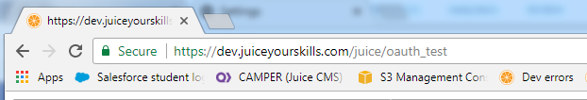

Firefox:

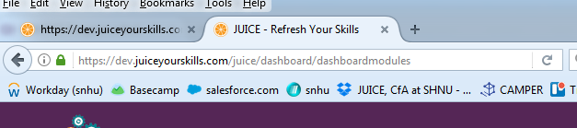

If that does not work, then you must clear your browser cache.

Firefox:

1. Choose **Clear Recent History** from the History menu
2. Set **Time Range to clear** to the desired time interval. “Everything” will ensure that you are clearing all older versions of the text files.

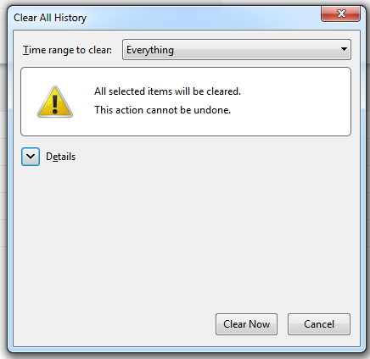

1. Click the **Details** down arrow and **uncheck all the boxes** except for Cache

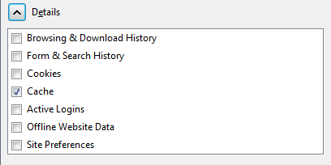

1. Click **Clear Now**.

Chrome:

1. Click the little dots and choose **History**, and then choose **History** again from the cascading menus.

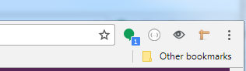

1. When the History page loads, click **Clear browsing data**.

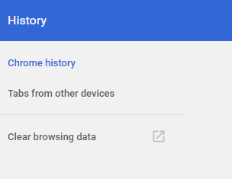

1. Make sure that only **Cached images and files** is selected:

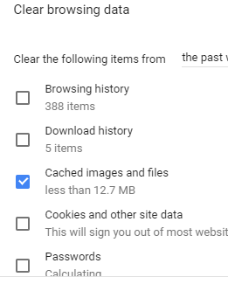

1. Click the blue **Clear Browsing Data** button